**Input**

Format

{

datetime: STRING : ”Date and time of message” (yyyy-mm-dd hh:mm:ss)

channel: STRING: ”Channel where the message was posted”

type: STRING: ”message type”

author: STRING: “account name / identifier of message author”

user_mentions: ARRAY OF STRING: [“account name(s) / identifier(s) of mentioned member(s)”]

role_mentions: ARRAY OF STRING: [“name(s) of mentioned role(s)”]

reactions: ARRAY OF ARRAYS OF STRING: “emoji type and all account name(s) / identifier(s) that sent this emoji”

replied_user: STRING: “if type is REPLY, account name / identifier of member that wrote the message that was replied to”

thread: BOOL: “whether message was sent in thread or not”

(optional) message_content: STRING: “content of the message”

}

Example

{

datetime: “2022-07-01 07:01:05”

channel: “community-health”

type: “REPLY”

author: “Ene SS Rawa#0855”

user_mentions: [“danielo#2815”, “katerinabc#6667”]

role_mentions: [“Community Health - Contributors”]

reactions: [[“danielo#2815”, “katerinabc#6667”, “â¤ï¸â€ðŸ”¥”], [“danielo#2815”, 766424138167615518”]]

replied_user: “WaKa#6616”

thread: False

message_content: “Good question. @danielo#2815 or @katerinabc#6667 can tell you more. This question applies to all @Community Health - Contributors”

}

**Ene SS Rawa#0855 (2022-07-01 07:01:05)**

Good question @WaKa#6616. @danielo#2815 or @katerinabc#6667 can tell you more. This question applies to all @Community Health - Contributors

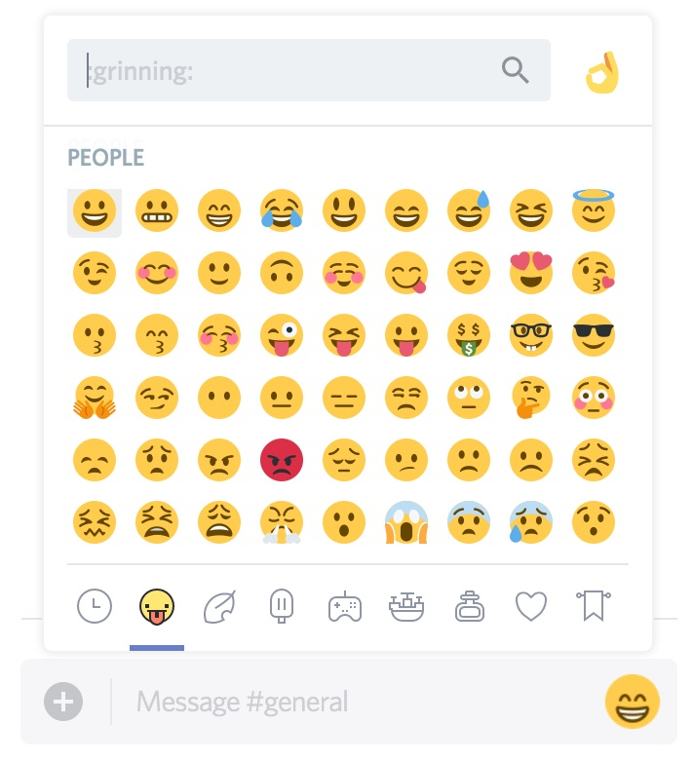

2



1

**WaKa#6616**

**Output**

Format

{

date: ARRAY OF STRING : [”Date(s) of the data”] (yyyy-mm-dd)

channel: ARRAY OF STRING: [”Channel(s) of the data”]

lone_messages: ARRAY: [Number of normal messages per hour]

thr_messages: ARRAY: [Number of thread messages per hour]

replies: ARRAY: [Number of normal replies per hour]

thr_replies: ARRAY: [Number of thread replies per hour]

mentions: ARRAY: [Number of normal mentions per hour]

thr_mentions: ARRAY: [Number of thread mentions per hour]

rep_mentions: ARRAY: [Number of replied mentions per hour]

emojis: ARRAY: [Number of emojis per hour]

}

Example

{

date: [“2022-07-02”]

channel: [“community-health”]

lone_messages: [0 0 0 0 0 0 0 0 1 0 0 0 0 0 0 1 0 1 0 0 0 0 0 0]

thr_messages: [0 0 0 0 0 0 0 0 0 0 0 0 0 0 0 0 0 0 0 0 1 0 0 0]

replies: [0 0 0 0 0 0 0 1 0 1 0 0 0 0 0 0 0 0 0 0 0 0 0 0]

thr_replies: [0 0 0 0 0 0 0 0 0 0 0 0 0 0 0 0 0 0 0 0 1 0 0 0]

mentions: [0 0 0 0 0 0 0 2 1 0 0 0 0 0 0 0 0 1 0 0 0 0 0 0]

thr_mentions: [0 0 0 0 0 0 0 0 0 0 0 0 0 0 0 0 0 0 0 0 1 0 0 0]

rep_mentions: [0 0 0 0 0 0 0 1 0 1 0 0 0 0 0 0 0 0 0 0 1 0 0 0]

emojis: [0 0 0 0 0 0 0 3 0 1 0 0 0 0 0 1 0 0 0 0 2 0 0 0]

}